**National University of Computer & Emerging Sciences, Karachi**

**Computer Science Department**

**Fall 2023, Lab Manual – 09**

|  |  |
| --- | --- |
| **Course Code: CL-217** | **Course : Object Oriented Programming Lab** |
| **Instructor(s) :** | **Shafique Rehman** |

**LAB - 9**

Nested Classes

**Nested Classes**

Java inner class or nested class is a class that is declared inside the class or interface.

It can access all the members of the outer class, including private data members and methods.

Syntax of Inner class

**class Java_Outer_class{**

**//code**

**class Java_Inner_class{**

**//code**

**}**

**}**

**Need of Java Inner class**

Sometimes users need to program a class in such a way so that no other class can access it. Therefore, it would be better if you include it within other classes.

If all the class objects are a part of the outer object then it is easier to nest that class inside the outer class. That way all the outer class can access all the objects of the inner class.

**Types of Nested classes**

There are two types of nested classes non-static and static nested classes. The non-static nested classes are also known as inner classes.

* Member inner class
* Anonymous inner class
* Local inner class

**Java Member Inner class**

A class that is created inside a class but outside a method is called member inner class. It is also known as a regular inner class. It can be declared with access modifiers like public, default, private, and protected.

**Example:**

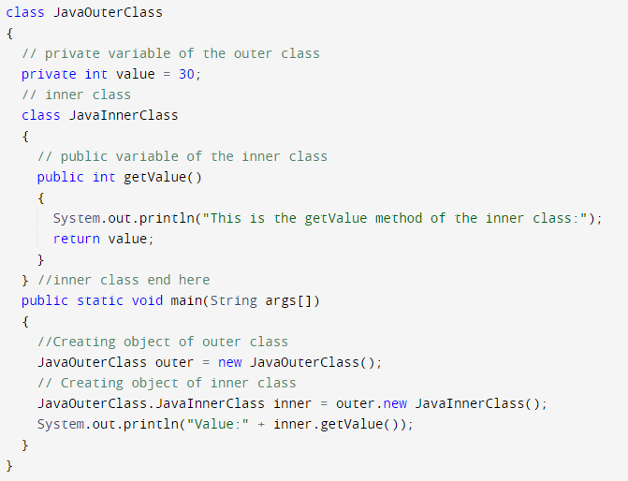In this example, we are creating a msg() method in the member inner class that is accessing the private data member of the outer class.

Output:

How to instantiate Member Inner class in Java?

An object or instance of a member's inner class always exists within an object of its outer class. The new operator is used to create the object of member inner class with slightly different syntax.The general form of syntax to create an object of the member inner class is as follows:

Syntax:

**OuterClassReference.new MemberInnerClassConstructor();**

Example:

**obj.new Inner();**

Here, OuterClassReference is the reference of the outer class followed by a dot which is followed by the new operator.

**Java Local inner class**

A class i.e., created inside a method, is called local inner class in java. Local Inner Classes are the inner classes that are defined inside a block. Generally, this block is a method body. Sometimes this block can be a for loop, or an if clause. Local Inner classes are not a member of any enclosing classes. They belong to the block they are defined within, due to which local inner classes cannot have any access modifiers associated with them. However, they can be marked as final or abstract. These classes have access to the fields of the class enclosing it.

If you want to invoke the methods of the local inner class, you must instantiate this class inside the method.

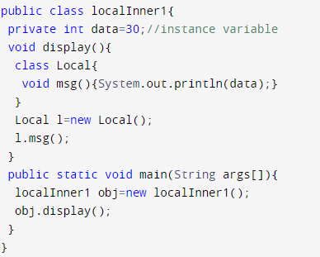**Java local inner class example**



Output:

**Java static nested class**

A static class is a class that is created inside a class, is called a static nested class in Java. It cannot access non-static data members and methods. It can be accessed by outer class name.

* It can access static data members of the outer class, including private.
* The static nested class cannot access non-static (instance) data members or

**Java static nested class example**

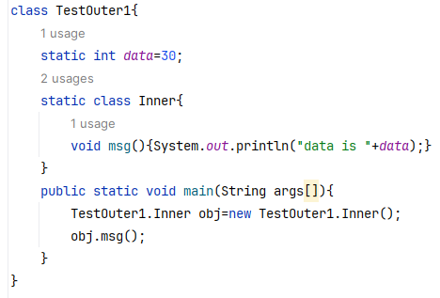

Lab Tasks

**Task 1:**

* Create a class named as “Job” that has role, ID and salary as private attributes.
* Make get and set for all the attributes.
* Create a class named as “Person” that has Job class as a member.
* Make a constructor that initializes the Job object and call the set salary function and set the value of your choice. Invoke the get salary function also using the job object.
* In the main program, create a Person object and display the salary.

**Task 2:**

* Consider a House class that has a Room class as one of its components. The Room class has attributes such as room type, room size, and room temperature.
* Write the House class with the Room class as its component, and include appropriate getter and setter methods for the Room object.
* Create an object of the House class and assign values to its attributes, including the Room object.
* Implement a method in the House class that displays the details of the house, including the details of the room.
* Write a short code snippet to create an object of the House class and display its details.

**Task 3:**

* Create a class named as “CPU” that has an attribute double price.
* Create a nested class “Processor” that has attributes double cores and String manufacturer. The class has a method double getCache( ) that returns 4.2.
* Create another nested protected class “RAM” that has attributes double memory and String manufacturer. The class has a method double getClockSpeed ( ) that returns 5.3.
* In the main program, create objects of the outer class as well as both the inner classes. Call both the functions.

**Task 4:**

Create a vehicle class having attributes vehicle name, engine cc, model as data members and a display function that list all the attributes of the vehicle. Now create a static inner class named as Owner that has data members as owners name, CNIC number and phone number of the owner. Write down proper setters/ getters and constructors for both the classes.

In main method create an object of class car using anonymous inner class and within that assign the owner to the car. The anonymous inner class should override the display method to show all the details of a car i.e. vehicle name, engine cc, model, Owners name and CNIC.

**Task 5:**

* Create a class named as “Car” that has attributes carname and cartype. Make a parameterized constructor to set these attributes. Make a private method getCarname( ) that returns car name.
* Create a class named as “Engine” that has an attribute engine type.
* Make a set engine function that first checks if the car type is equal “4T”. If the condition matches, it checks if the car name is equal “Mehran” and set the engine type to small or else set the engine type to large. If not, set the engine type to “Bigger”.
* The class has a method getEngineType that returns engine type.
* In the main program, create objects of the outer class as well as for the inner class. Call the functions as appropriate.